Mandatory Public Disclosure
A. GENERAL INFORMATION:
Sr. No. | INFORMATION | DETAILS
1 | NAME OF THE SCHOOL | GOVERNMENT MODEL SANSKRITI SENIOR SECONDARY SCHOOL, ARYA NAGAR, HISAR
2 | AFFILIATION NO. | 520075
3 | SCHOOL CODE | 1423
4 | COMPLETE ADDRESS WITH PIN CODE | GMSSSS, VPO arya nagar,hisar, 125001
5 | PRINCIPAL NAME & QUALIFICATION | Sh. Manoj Kumar, M.Sc.
6 | SCHOOL EMAIL ID | www.gmssssaryanagarhisar.com
7 | CONTACT DETAILS | 01662-264030

B. DOCUMENTS AND INFORMATION
Sr. No. | DOCUMENTS AND INFORMATION | UPLOAD DOCUMENTS
1 | COPIES OF AFFILIATION/UPGRADATION LETTER AND RECENT EXTENSION OF AFFILIATION, IF ANY | N/A
2 | COPIES OF SOCIETIES / TRUST / COMPANY REGISTRATION / RENEWAL CERTIFICATE. AS APPLICABLE | N/A
3 | COPY OF NO OBJECTION CERTIFICATE (NOC) ISSUED, IF APPLICABLE, BY THE STATE GOVT. / UT
4 | COPIES OF RECOGNITION CERTIFICATE UNDER RTE ACT, 2009, AND IT’S RENEWAL IF APPLICABLE | N/A
5 | COPY OF VALID BUILDING SAFETY CERTIFICATE AS PER THE NATIONAL BUILDING CODE | To be found in download section
6 | COPY OF VALID FIRE SAFETY CERTIFICATE ISSUED BY THE COMPETENT AUTHORITY | To be found in download section
7 | COPY OF THE DEO CERTIFICATE SUBMITTED BY THE SCHOOL FOR AFFILIATION / UPGRADATION / EXTENSION OF AFFILIATION OR SELF CERTIFICATION BY SCHOOL
8 | COPIES OF VALID WATER, HEALTH AND SANITATION CERTIFICATES | To be found in download section

NOTE: THE SCHOOL NEEDS TO UPLOAD THE SELF ATTESTED COPIES OF ABOVE LISTED DOCUMENTS BY CHAIRMAN / MANAGER / SECRETARY AND PRINCIPAL. IN CASE, IT IS NOTICED AT LATER STAGE THAT UPLOADED DOCUMENTS ARE NOT GENUINE THEN SCHOOL SHALL BE LIABLE FOR ACTION AS PER NORMS.

C: RESULT AND ACADEMICS:
Sr. No. | DOCUMENTS / INFORMATION | UPLOAD DOCUMENTS
1 | FEE STRUCTURE OF THE SCHOOL | 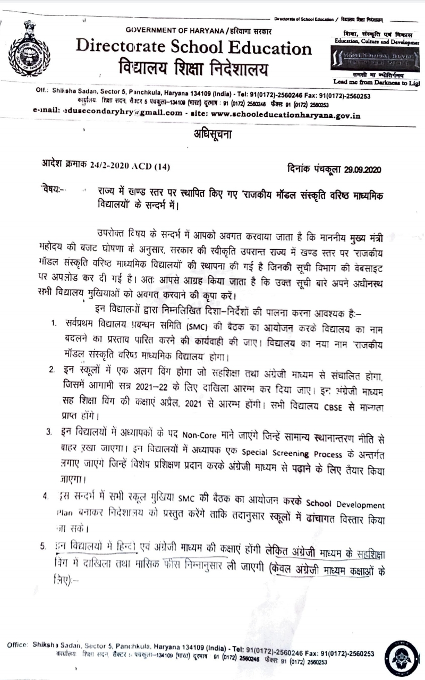
 |  | 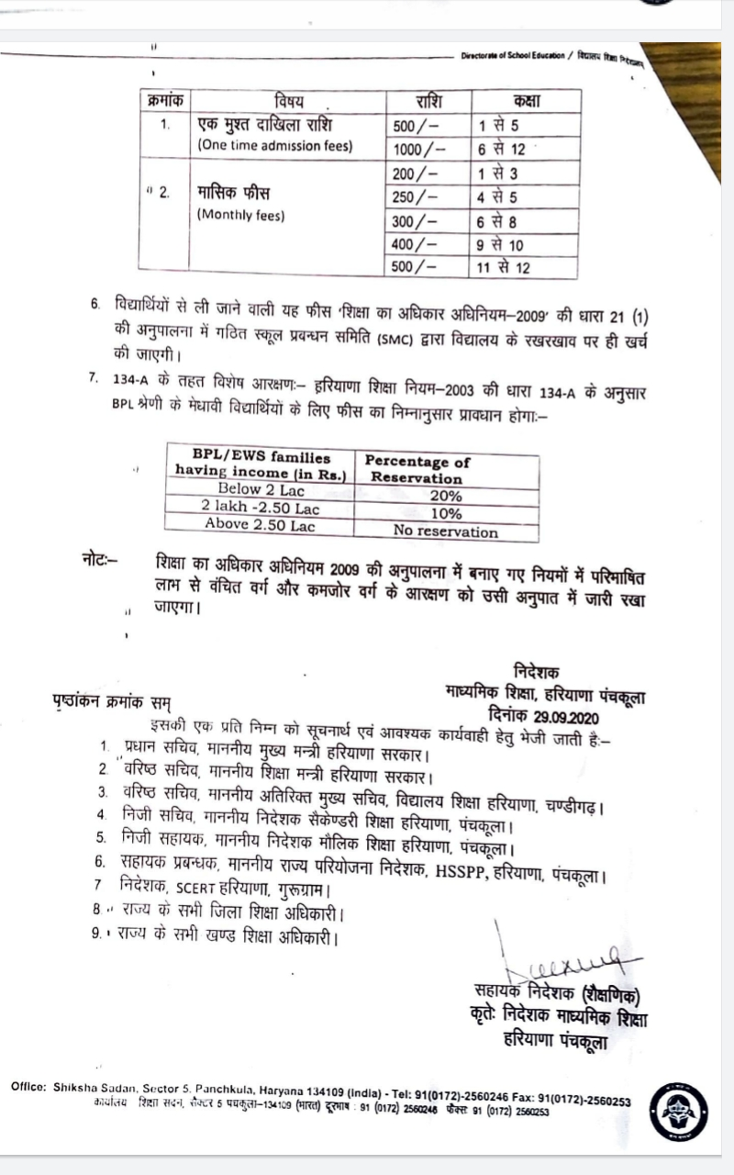
2 | ANNUAL ACADEMIC CALENDAR | To be found in admission section
3 | LIST OF SCHOOL MANAGEMENT COMMITTEE (SMC) | To be found in committee member section
4 | LIST OF PARENTS TEACHERS’ ASSOCIATION (PTA) MEMBERS
5 | LAST THREE-YEAR RESULT OF THE BOARD EXAMINATIONS AS PER APPLICABLE | Affiliated to CBSE w.e.f. 01-05-2021

RESULT CLASS: X
Sr. No. | YEAR | NO. OF REGISTERED STUDENTS | NO. OF STUDENTS PASSED | PASS PERCENTAGE | REMARKS

RESULT CLASS: XII
Sr. No. | YEAR | NO. OF REGISTERED STUDENTS | NO. OF STUDENTS PASSED | PASS PERCENTAGE | REMARKS

D: STAFF (TEACHING)
Sr. No. | INFORMATION | DETAILS
1 | PRINCIPAL | 01
2 | TOTAL NO. OF TEACHERS | 31
 | #PGT | 22
 | #TGT | 2
 | #PRT | 7
3 | TEACHERS SECTION RATIO
4 | DETAILS OF SPECIAL EDUCATOR | Sangeeta,M.Sc.,B.ED.,Pooja,M.A.,B.ed.
5 | DETAILS OF COUNSELLOR AND WELLNESS TEACHER

E: SCHOOL INFRASTRUCTURE:
Sr. No. | INFORMATION | DETAILS
1 | TOTAL CAMPUS AREA OF THE SCHOOL (IN SQ. MTR) | 9000
2 | NO. AND SIZE OF THE CLASS ROOMS (IN SQ. MTR) | 37 Rooms
3 | NO. AND SIZE OF LABORATORIES INCLUDING COMPUTER LABS (IN SQ.MTR) | 7 laboratories and size is appx.75 sq.mtr.
4 | INTERNET FACILITY ( Y / N) | Y
5 | NO. OF GIRLS TOILETS | 1
6 | NO. OF BOYS TOILETS | 2
7 | LINK OF YOUTUBE VIDEO OF THE INSPECTION OF SCHOOL COVERING THE INFRASTRUCTURE OF THE SCHOOL | _

